VAPT 3rd Report
1 – Advanced Exploitation and Web Application Testing Lab
Target: http://192.168.0.125/dvwa
Tools: Nmap, Owasp ZAP, Nikto

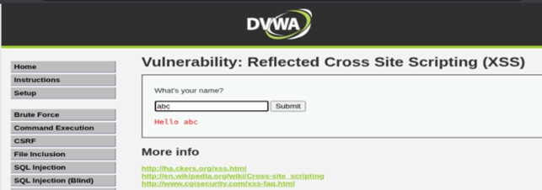

XSS – generating remote alert
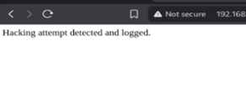

XSS - inserting script to retrieve cookies

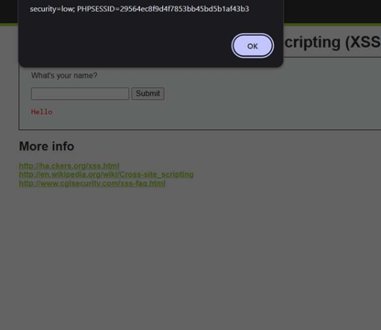

Vulnerability | Severity | URL
Remote Code Execution - CVE2012-1823 | High | http://192.168.0.125/dvwa/?d+allow_url_include%3d1+d+auto_prepend_file%3dphp://input
 |  | http://192.168.0.125/dvwa/login.php?d+allow_url_include%3d1+d+auto_prepend_file%3dphp://input
Source Code Disclosure - CVE2012-1823 | High | http://192.168.0.125/dvwa/?-s
 |  | http://192.168.0.125/dvwa/login.php?-s
Content Security Policy (CSP) Header Not Set | Medium | http://192.168.0.125/dvwa
 |  | http://192.168.0.125/dvwa/login.php
 |  | http://192.168.0.125/robots.txt
 |  | http://192.168.0.125/sitemap.xml
Directory Browsing | Medium | http://192.168.0.125/dvwa/dvwa/
 |  | http://192.168.0.125/dvwa/dvwa/css/
 |  | http://192.168.0.125/dvwa/dvwa/images/
Hidden File Access | Medium | http://192.168.0.125/phpinfo.php
Missing Anti-clickjacking Header | Medium | http://192.168.0.125/dvwa
 |  | http://192.168.0.125/dvwa/login.php
Cookie No HttpOnly Flag | Low | http://192.168.0.125/dvwa/
Cookie without SameSite Attribute | Low | http://192.168.0.125/dvwa/
Server Leaks via "X-PoweredBy" HTTP Response Header Field(s) | Low | http://192.168.0.125/dvwa
 |  | http://192.168.0.125/dvwa/login.php
Server Leaks via "Server" HTTP Response Header Field | Low | http://192.168.0.125/dvwa
 |  | http://192.168.0.125/dvwa/
 |  | http://192.168.0.125/dvwa/dvwa/css/login. css
 |  | http://192.168.0.125/dvwa/dvwa/images/l ogin_logo.png
 |  | http://192.168.0.125/dvwa/dvwa/images/R andomStorm.png
 |  | http://192.168.0.125/dvwa/login.php
 |  | http://192.168.0.125/robots.txt
 |  | http://192.168.0.125/sitemap.xml
 |  | http://192.168.0.125/dvwa/login.php

2 – Post-Exploitation Evidence collection
Alert generated on the web

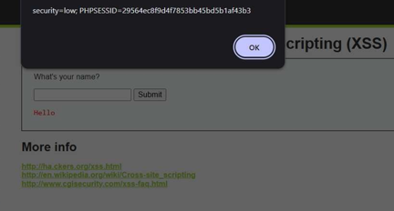

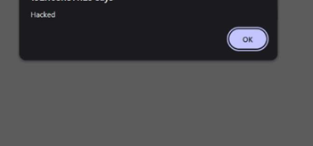

3 – Technical summary
A penetration test was performed on DVWA and Kioptrix using Kali Linux. Enumeration revealed RCE (CVE-2012-1823), XSS, CSP misconfiguration, directory browsing, and insecure cookies. Exploitation achieved remote command execution and shell access. Post-exploitation confirmed system exposure due to outdated services and missing security headers. Evidence and attack logs were collected .

4 – Non technical summary
A security assessment was conducted on the DVWA and Kioptrix environments to identify weaknesses that attackers could exploit. Several high-risk issues were found, including a remote code execution flaw and misconfigured security controls. These vulnerabilities allowed unauthorized system access and exposure of sensitive information. Additional medium-risk issues, such as missing security headers, directory browsing, and insecure cookies, increased the overall attack surface. After exploiting the system, we demonstrated how an attacker could gain control and extract data. To reduce risk, the system should be updated, patching applied, and secure configurations implemented. Overall security can improve significantly with regular maintenance and reviews.

